Placement Guide

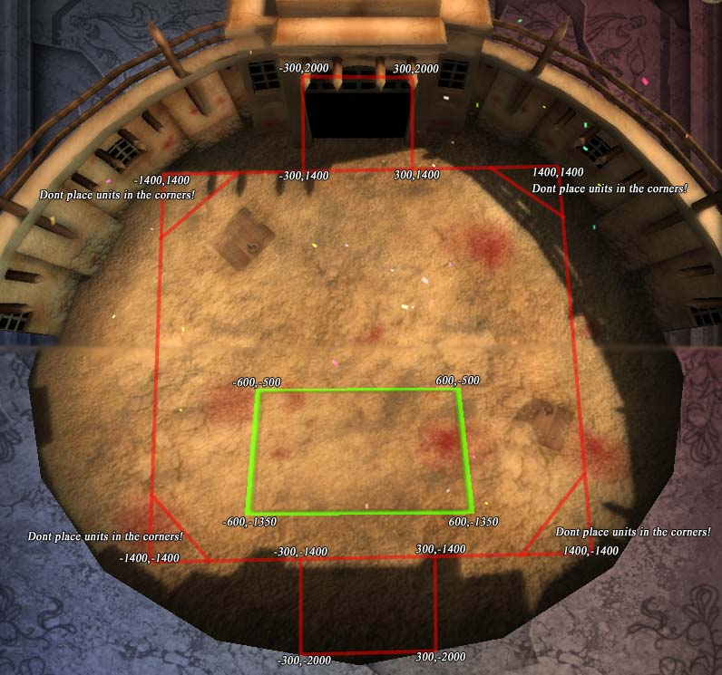

Unit Placement Notes:
Units should not be placed in the corners as they are outside the level boundaries, if you placing a unit on the edge with a position value of 1400 make sure the other value is not greater then 1100 on the negative or positive. I repeat, don't use the corners!

Some units have different sizes, and you need to make sure you space them apart from each other so they collide correctly. A good starting point is 200 units apart, larger units will need more space.

Level Files and Instructions:
All level files must be placed in the "levels" folder and must have a .kel extension, like the sample level already placed in your levels folder for you to try edit:

example.kel

To load a file you have created go to Skirmish from the main menu and then Custom Level.

The level file must be in a very specific format. You cannot leave empty, extra or missing lines or the game will probably crash when it tries to load the level. The lines without a = sign in them are just comment lines, They can be edited, but they MUST remain as a single line.

The first line is just comments.

The next 10 lines determine what heroes are available to the player, a 1 will allow the player to use that unit, 0 will restrict it's use:

Swordsmen=0
Archer=0
Healer=0
Necro=0
Monk=0
Druid=0
Bard=0
Pirate=0
Paladin=0
Elementalist=0

Next line is how much gold the player has to spend:

Gold=0

Next line is if the player is allowed to place units or if they will be placed by the level:

Custom Hero Placement(1 for yes 0 for no)=1

Only include the next section if the Custom Hero Placement is 1, it determines the number of heroes and where they are placed.

The first line is the number of heroes, do not set this over 9 or the level will not load:

Numberofheros=2

For each hero, two in this case you need the following lines:

Hero1=2
PositionX=-600
PositionY=-600

The Hero number determines which hero will be placed, see the list below for their numbers. The Position X and Y determine where the hero will be placed. You need to make sure you place them inside the level bounds, see the image above.

So if you have two heroes then you need those three lines for each of them like so:

Hero1=2
PositionX=-600
PositionY=-600
Hero2=9
PositionX=-400
PositionY=-600
Remember that if you change the number of heroes you will need to add or remove these lines accordingly, and if you change the custom hero placement to 0 you need to remove all these lines as well as the "numberofheros=" line.

Next line determines the number of waves of enemies there will be:

Waves=2

For each wave you will need a section like this:

Wave 1
Time to next wave=19
Number of Enemies=1
Enemy 1 type=21
PositionX=0
PositionY=1700

"Time to next wave=19" will determine how long tell the next wave starts in seconds.

"Number of Enemies=1" is how many Enemies will spawn for this wave.

For EACH enemy you need those next three lines. The first (Enemy Type=12) tells what type of enemy to spawn, see the list below for their number. The Position X and Y tell where to spawn the enemy.

Each additional wave is similar to the first with the following exceptions, you need two lines after the Position X and Y like this:

Wave 2
Time to next wave=18
Number of Enemies=2
Enemy 1 type=21
PositionX=-1200
PositionY=-1000
Going to PositionX=-800
Going to PositionY=-800
Enemy 2 type=21
PositionX=-1200
PositionY=-1200
Going to PositionX=-800
Going to PositionY=-1000

These are the positions the enemy will move to after they spawn. You must have these lines for each enemy or the game will crash when it tries to load the level.

You can add as many waves as you like as long as you make sure you have all the lines for each enemy in each wave.

If you are having problems with a level loading go through the whole file and make sure you do not have any extra, missing or blank lines. Look at the example file for a template to start editing. Also remember that any line that does not include a = is a comment line, it can be changed but it CANNOT BE REMOVED.

Hero Unit List:

1 = Swordsman
2 = Archer
3 = Priest
4 = Necromancer
5 = Monk
6 = Druid
7 = Bard
8 = Pirate
9 = Paladin
10 = Elementalist
11 = Necromancer Skeleton
25 = Elementalist Familiar

Enemy Unit List:
12 = Kobold
13 = Goblin Archer
14 = Giant Leech
15 = Ogre
16 = Goblin Shaman
17 = Giant Flaming Bear
18 = Zombie
19 = Mummy
20 = Skeleton Archer
21 = Doom Spider
22 = Abomination
23 = Death Knight
24 = Skeleton Warrior
26 = War Pig
27 = Warg
28 = Warg Rider
29 = Minotaur
30 = Centaur
31 = Goblin Bomber
33 = Drake

Here is the example.kel, a working level file to mess with:

Heroes Available (0 for unavailable or 1 for available)
Swordsmen=0
Archer=0
Healer=0
Necro=0
Monk=0
Druid=0
Bard=0
Pirate=0
Paladin=0
Elementalist=0
Gold=0
Custom Hero Placement(1 for yes 0 for no)=1
Numberofheros=3
Hero1=1
PositionX=-200
PositionY=-1000
Hero2=1
PositionX=200
PositionY=-1000
Hero3=2
PositionX=0
PositionY=-1200
Waves=2
Wave 1-----------------------------------------------------------------
Time to next wave=30
Number of Enemies=2
Enemy 1 type=12
PositionX=-200
PositionY=800
Enemy 2 type=12
PositionX=200
PositionY=800
Wave 2----------------------------------------------------------
Time to next wave=0
Number of Enemies=2
Enemy 1 type=13
PositionX=-150
PositionY=1500
Going to PositionX=-200
Going to PositionY=1200
Enemy 2 type=13
PositionX=150
PositionY=1500
Going to PositionX=200
Going to PositionY=1200

